**JAVA VERSION:**

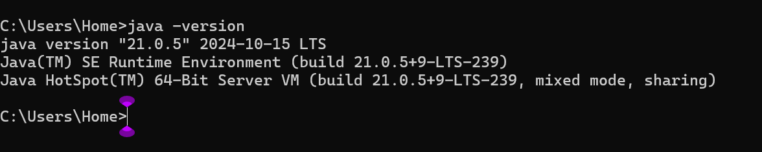

**INSTALLATION OF MAVEN:**

Step 1: Check whether maven is present in your system or not

Step 2: Go to Google type download maven and click on download Apache maven.

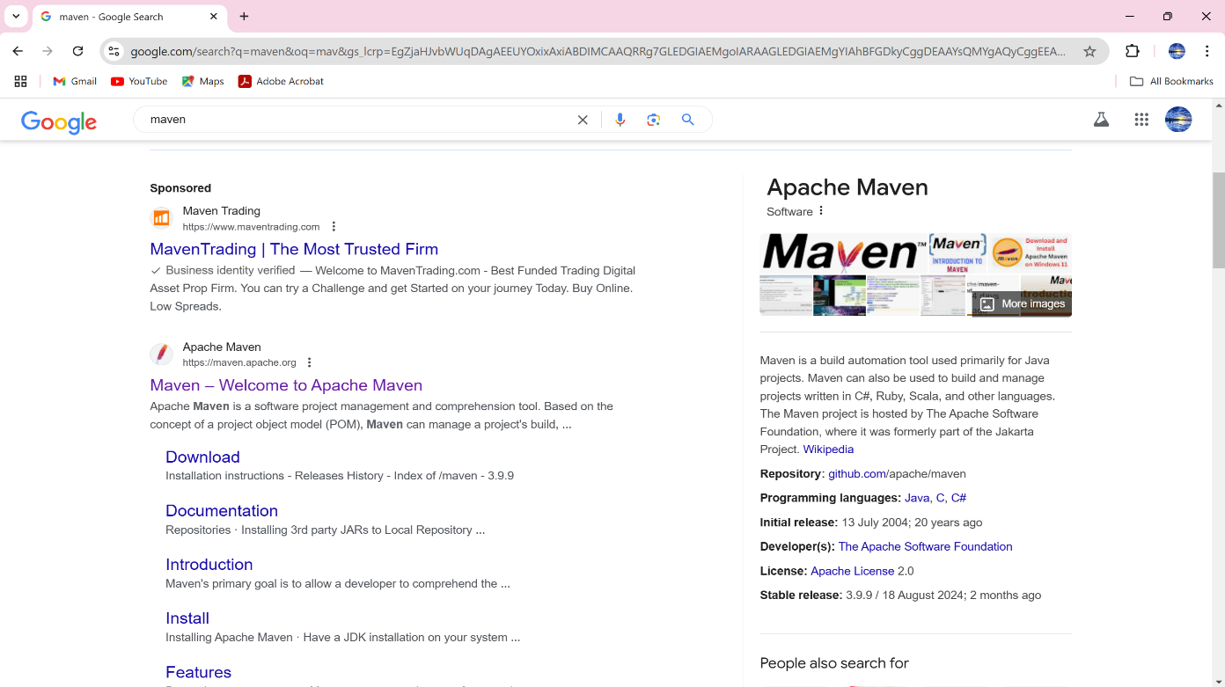

Step 3: Open the Maven Official Webpage

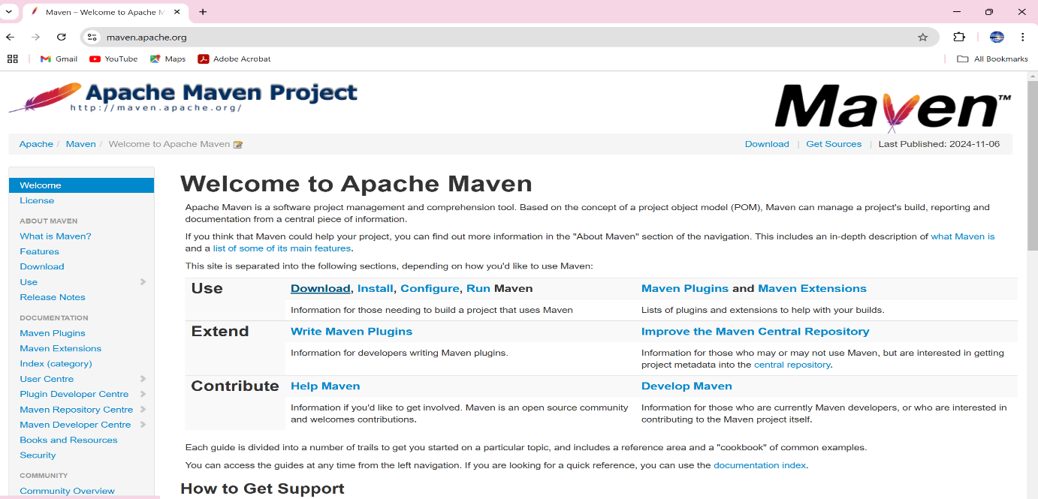

Step 4: Scroll down to go to downloading links.

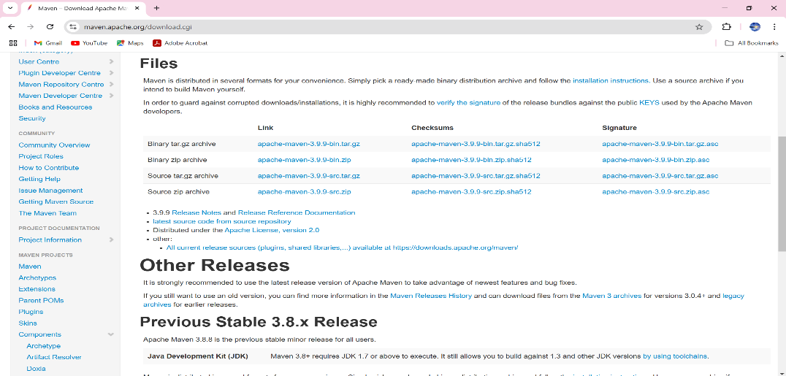

Step 5: click on apache-maven-3.3.9-bin zip.

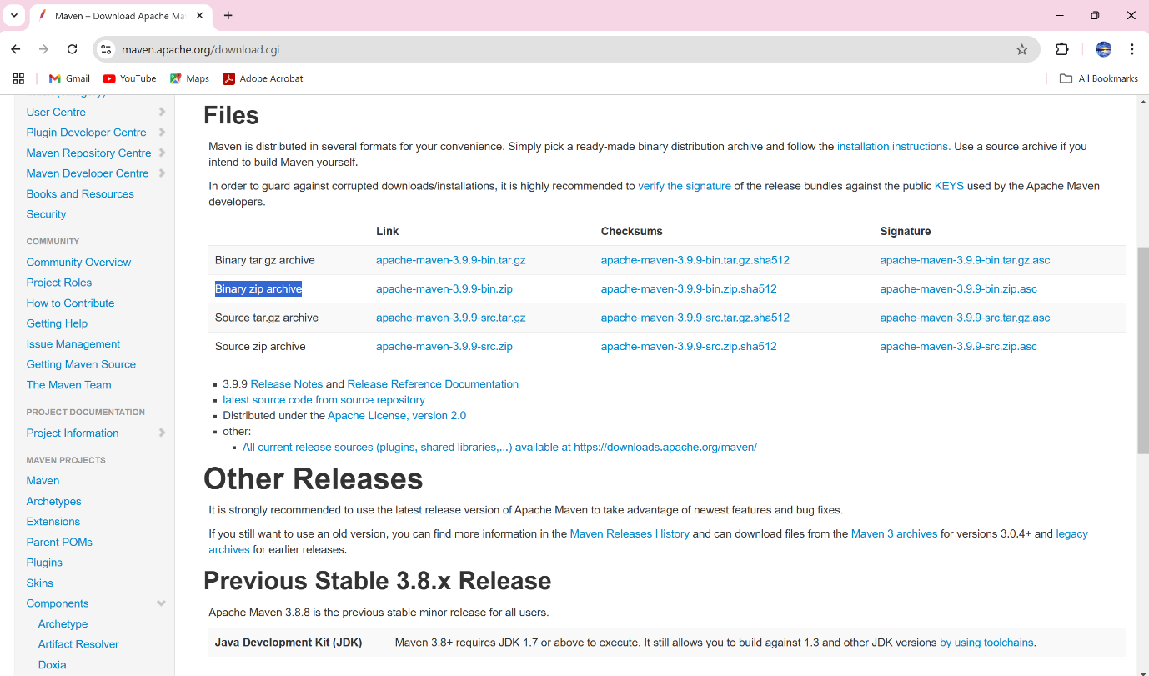

Step 6: extract zip file.

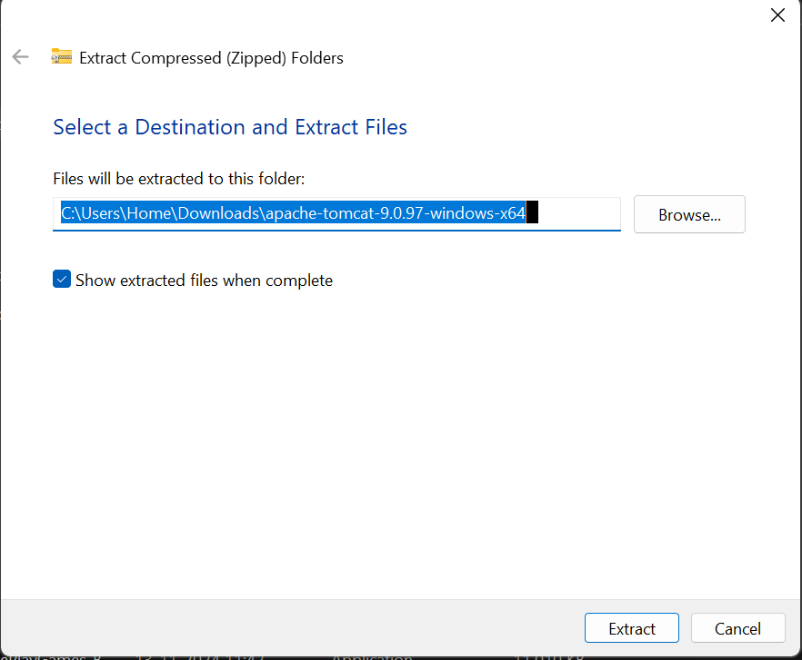

Step 7: set environment variables.

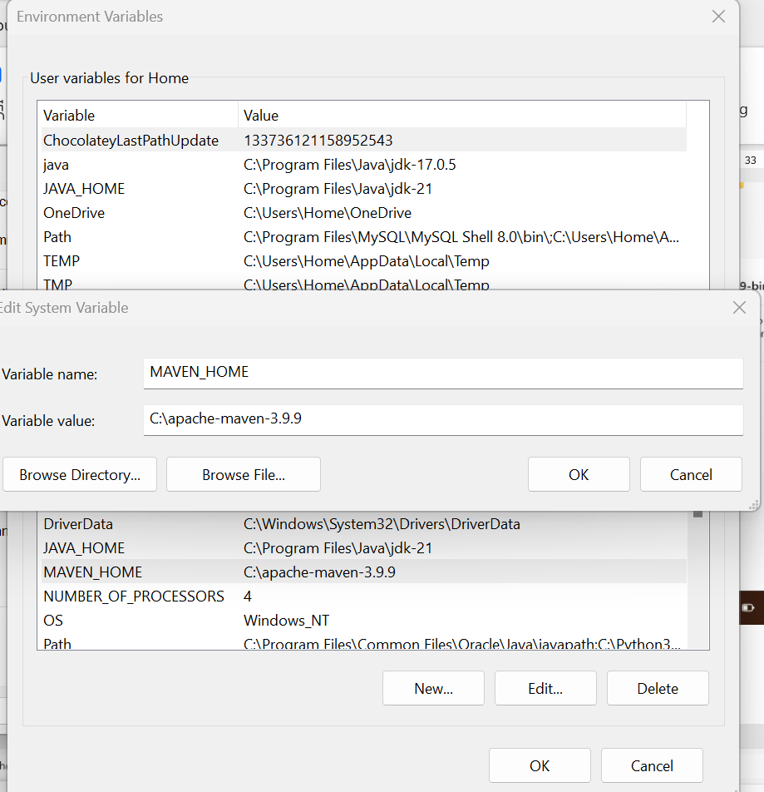

Step 8: Edit path.



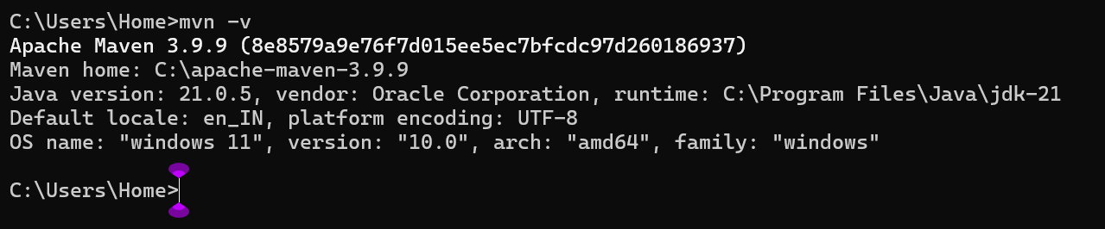

**INSTALLATION OF APACHE TOMCAT:**

**Step1:** Download the tomcat from the first link.

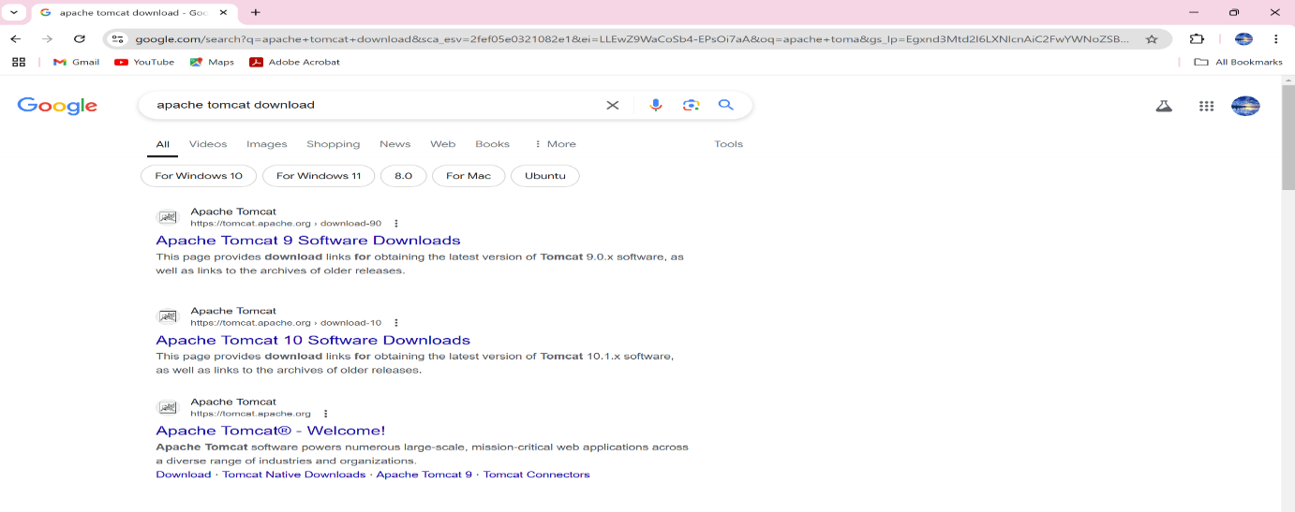

**Step 2:** Click on the following link 64-bit windows zip to download the zip file.

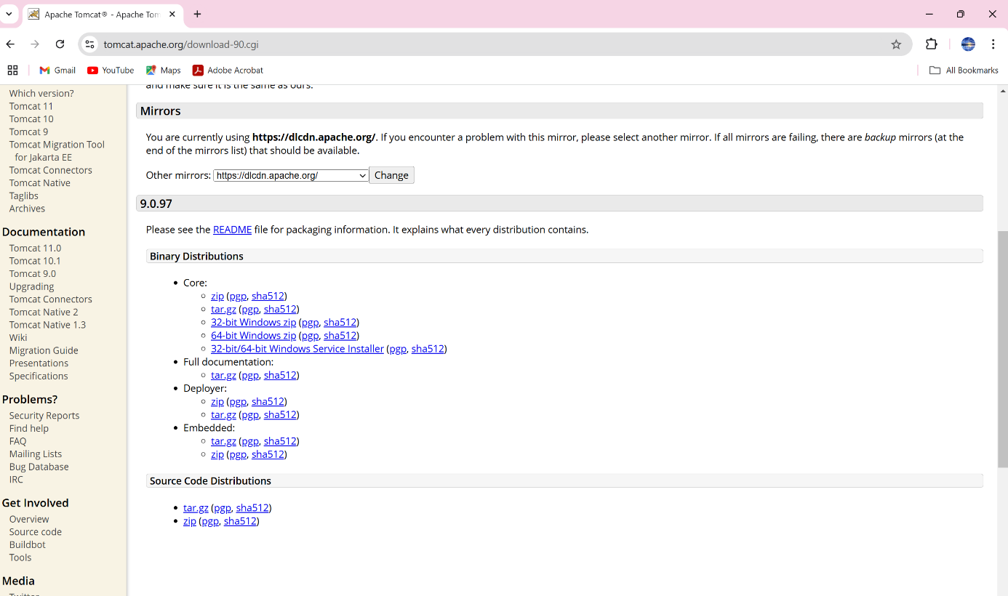

**Step 3:** We can view the downloaded file from Downloads. 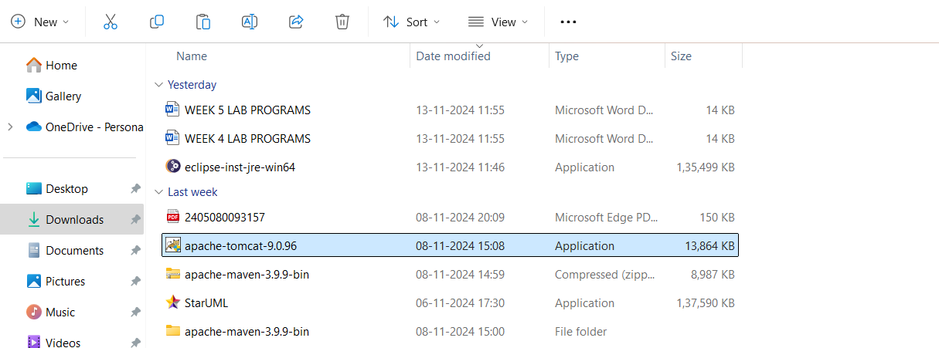

* Run the installer file you just downloaded.

Follow the setup wizard:

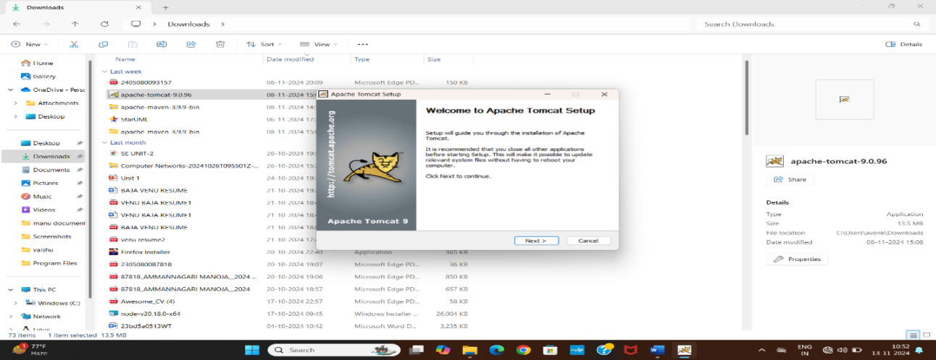

* Accept the license agreement.

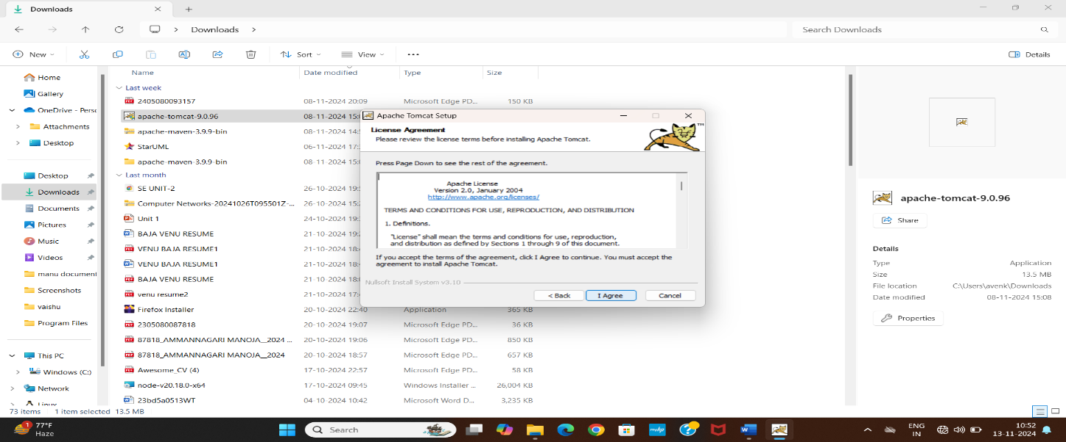

* Choose Full Installation (recommended for most cases)

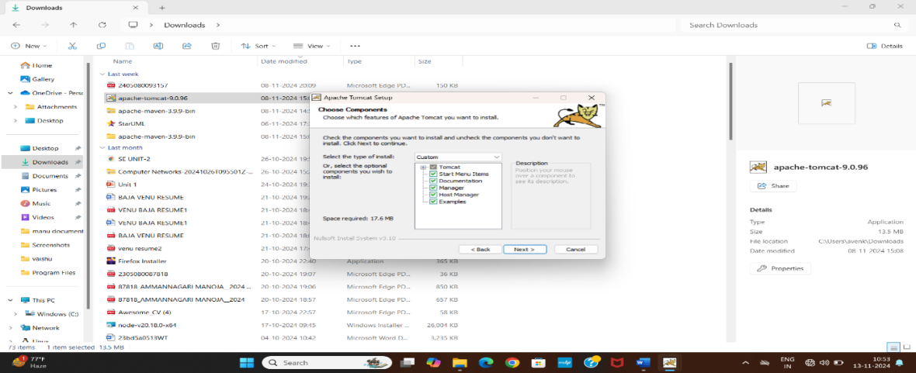

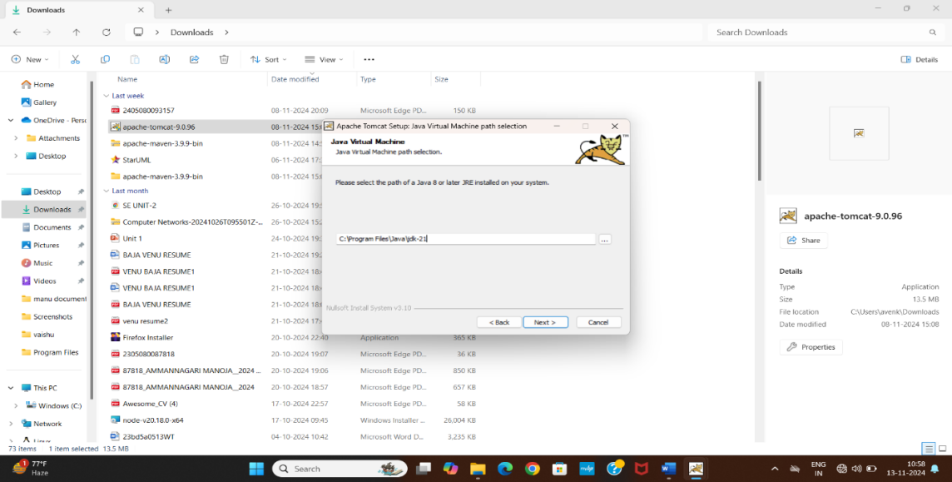

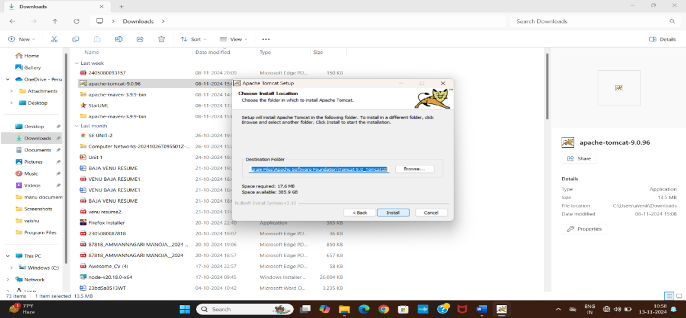

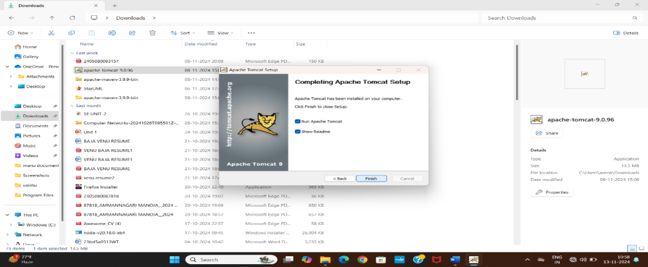

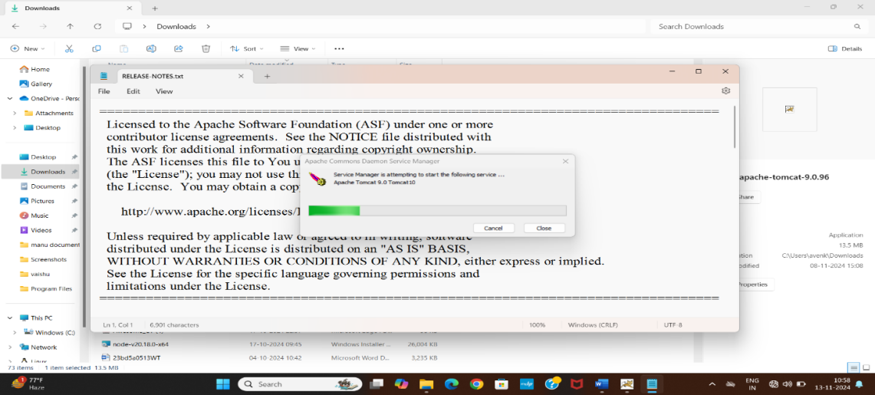

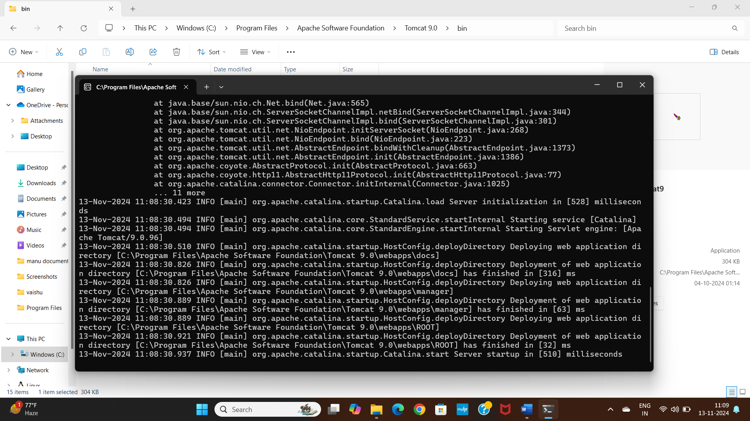

* Open the Windows Start Menu and look for Apache Tomcat.
* Start Tomcat by clicking on Tomcat Monitor or Tomcat Service.

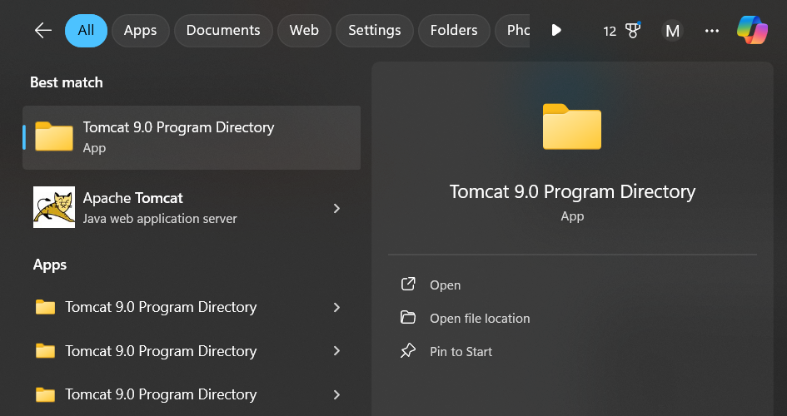

**INSTALLATION OF ECLIPSE IDE:**

**Step1:** Download the Eclipse.

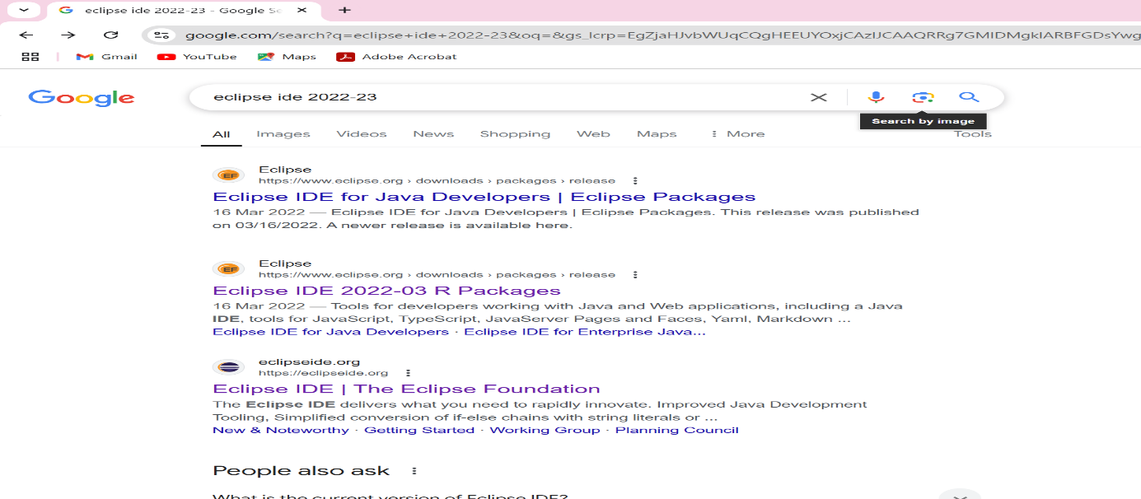

**Step 2:** Click on the windows zip to download the zip file.

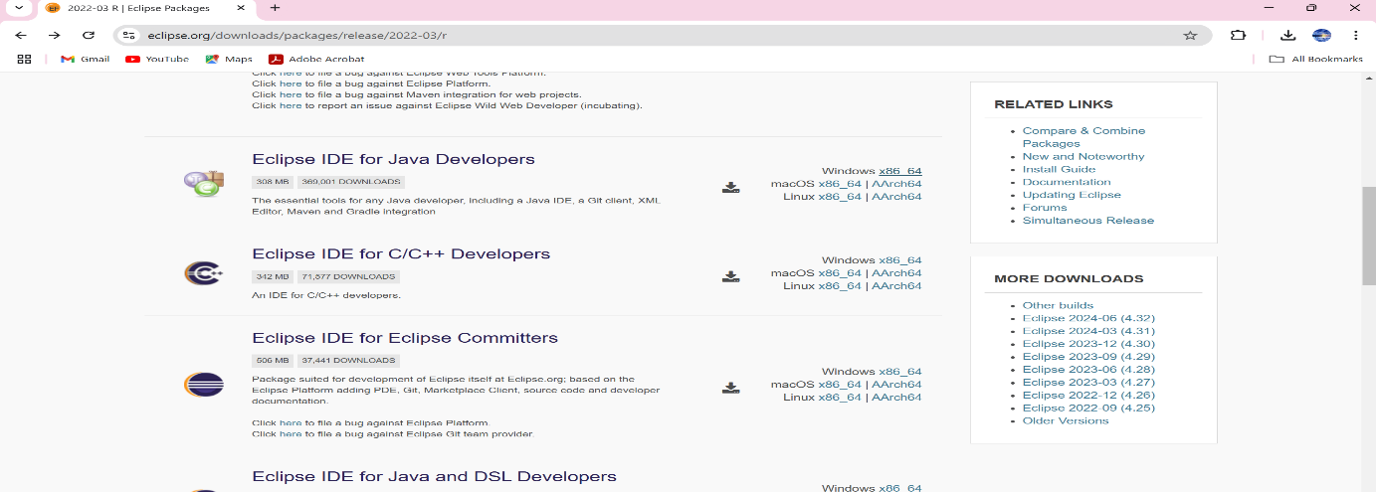

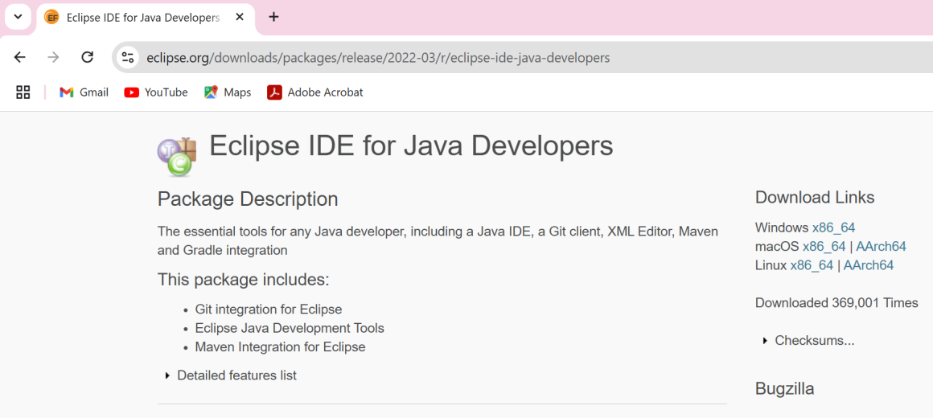

**Step 3:** We can view the downloaded file from Downloads.

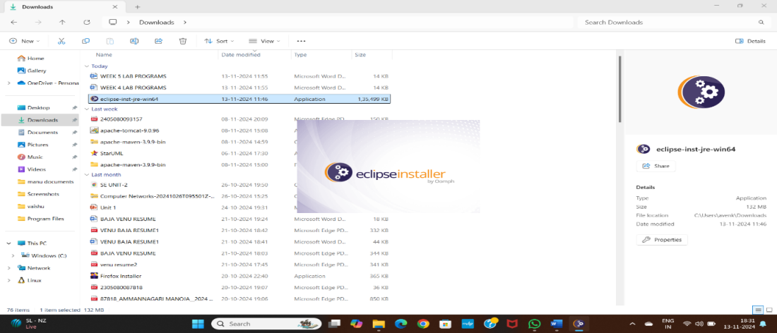

**Step 4:** Then, click on “**Eclipse IDE for Java Developers”**.

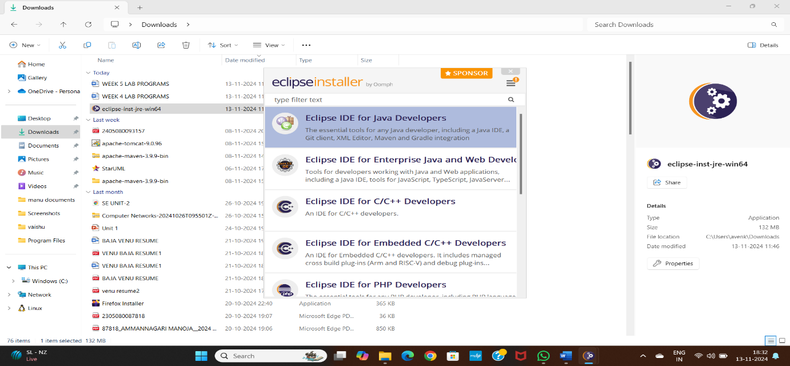

**Step 5:** Then, click on the “**Install**” button.

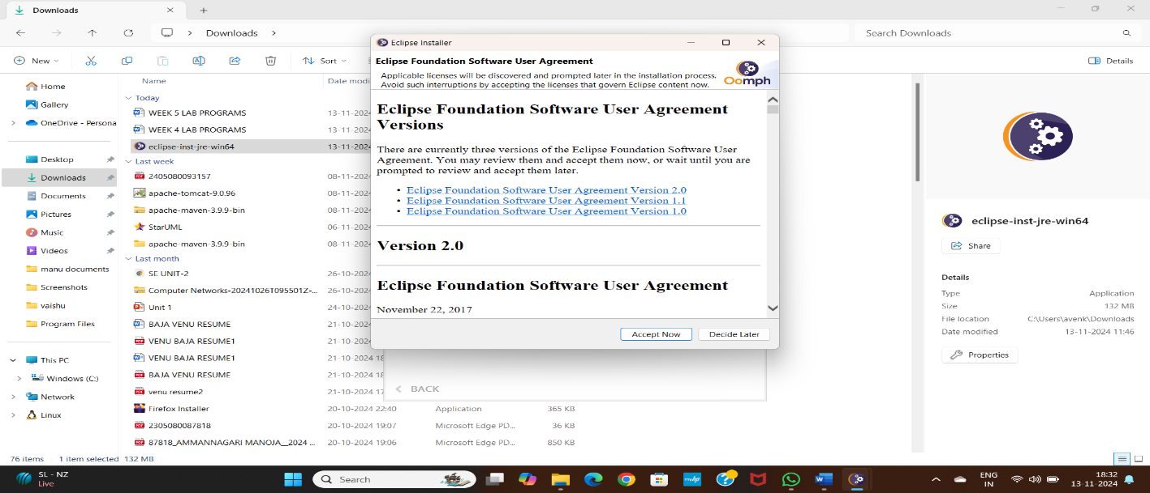

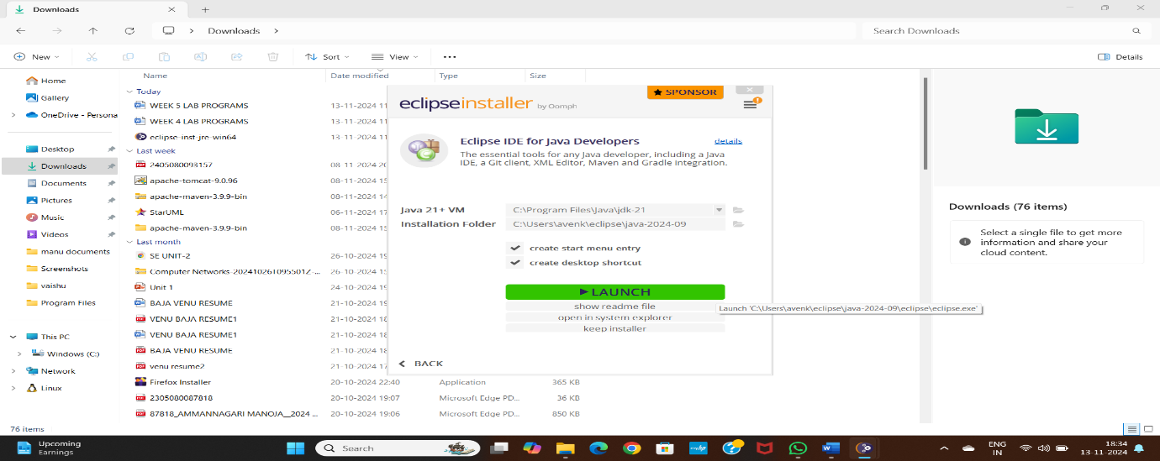

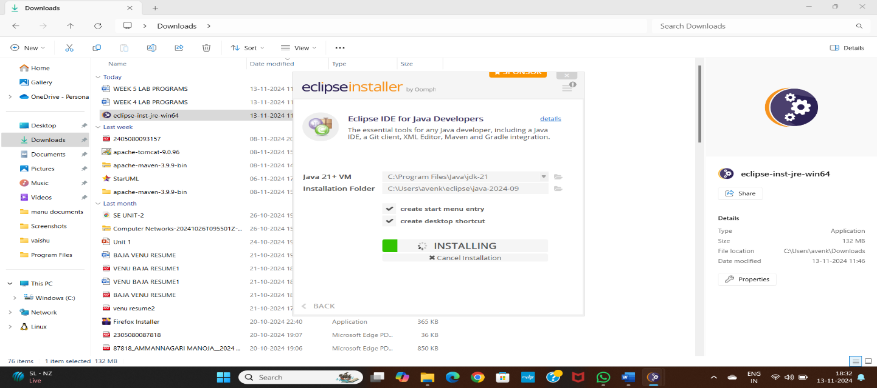

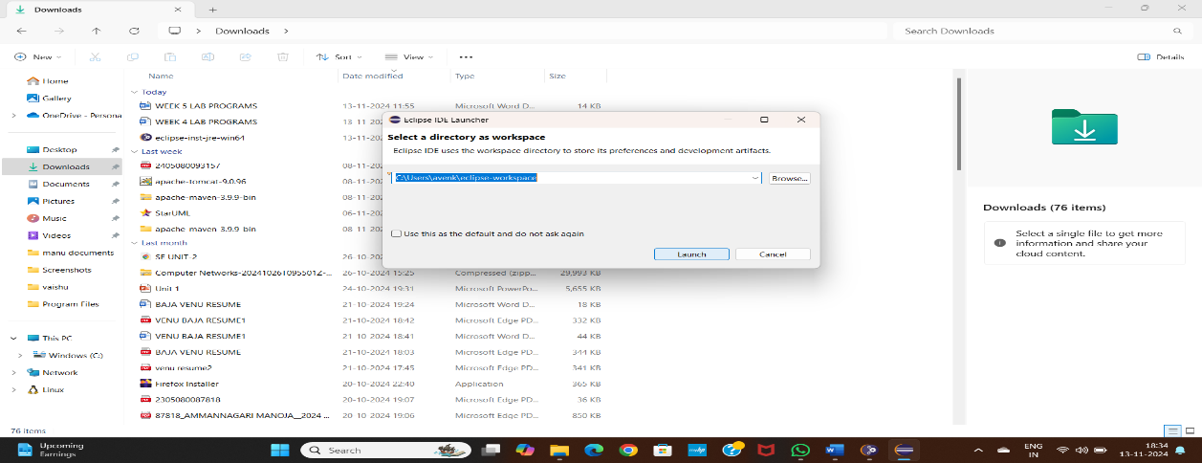

**Step 6:** Now click on “Create a new Java project”.

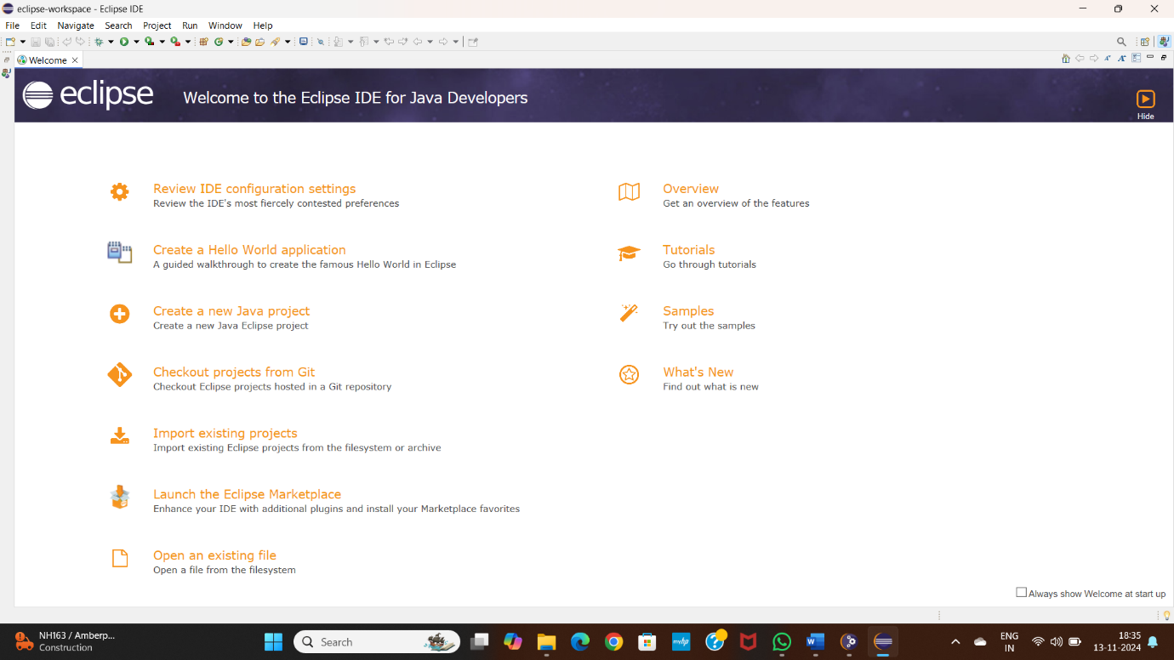

**Configuration of Apache Tomcat Server with Eclipse IDE**

**Step1:**Install updates into eclipse

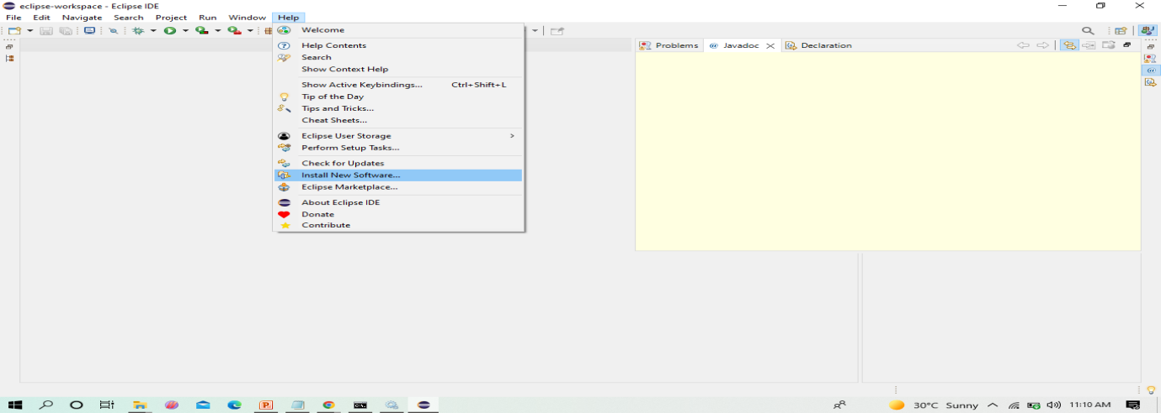

**Step2:** Before installing server into eclipse, we need to add Java EE to the eclipse IDE

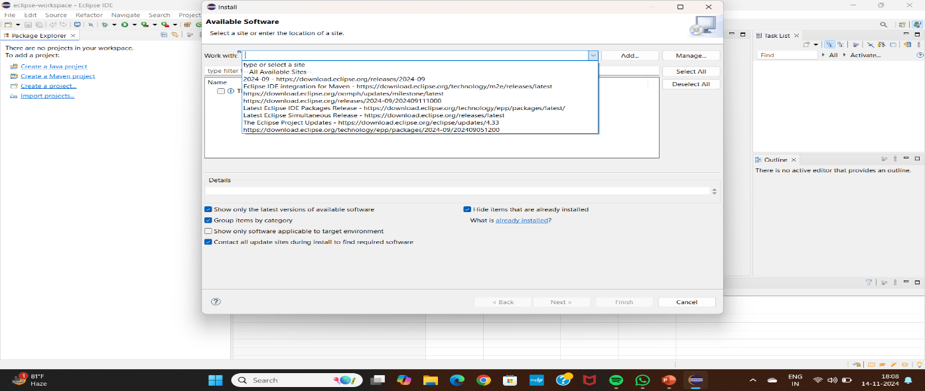

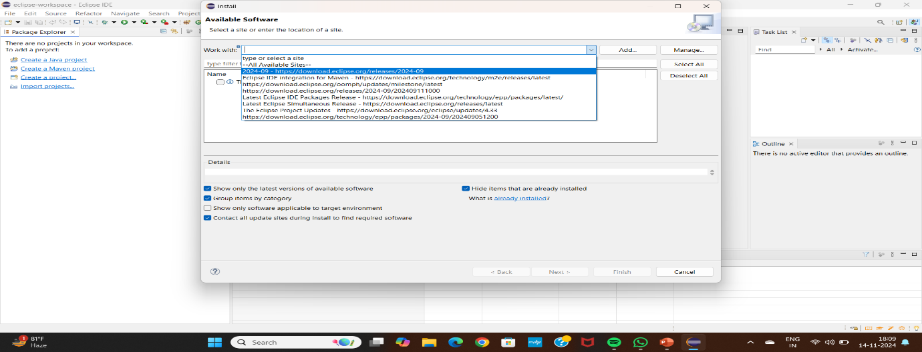

**Step3:** Click on the drop down menu in Work with and select the following from the list

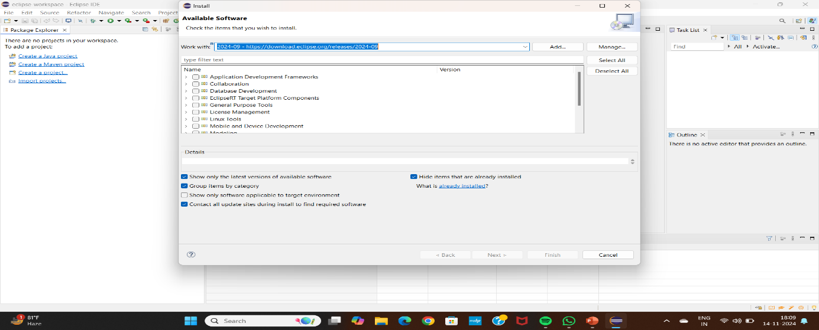

**Step4:** Check the Web,XML,JAVA EE box to install the latest software into eclipse in order to execute the dynamic web projects, maven web projects. Etc.

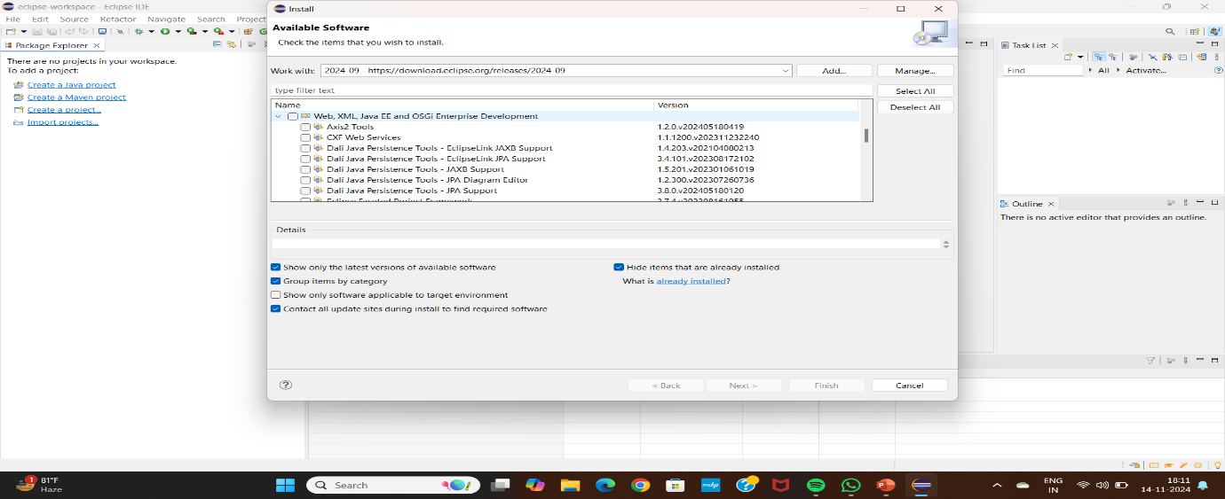

**Step 5:** Since we develop only Maven web project in DevOps, we can only check the shown two and click on next.

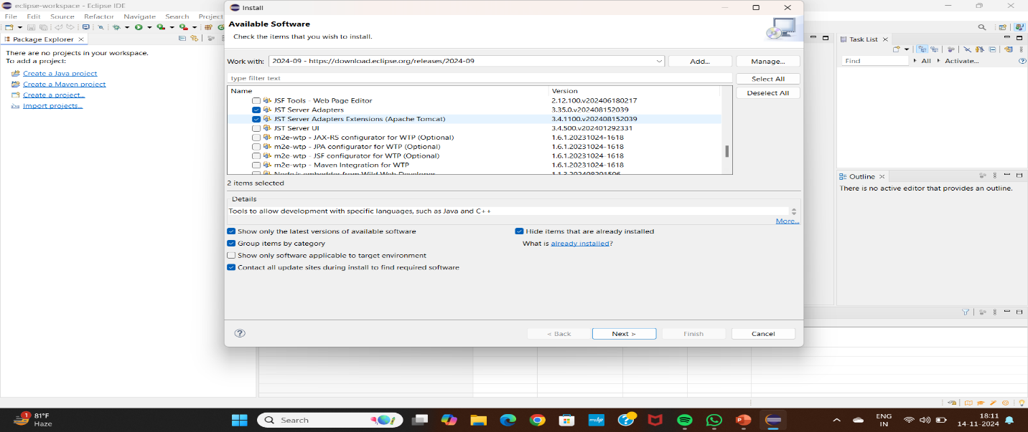

**Step 6:** Here enable the JST Adapter and JST server adapter and Install them.

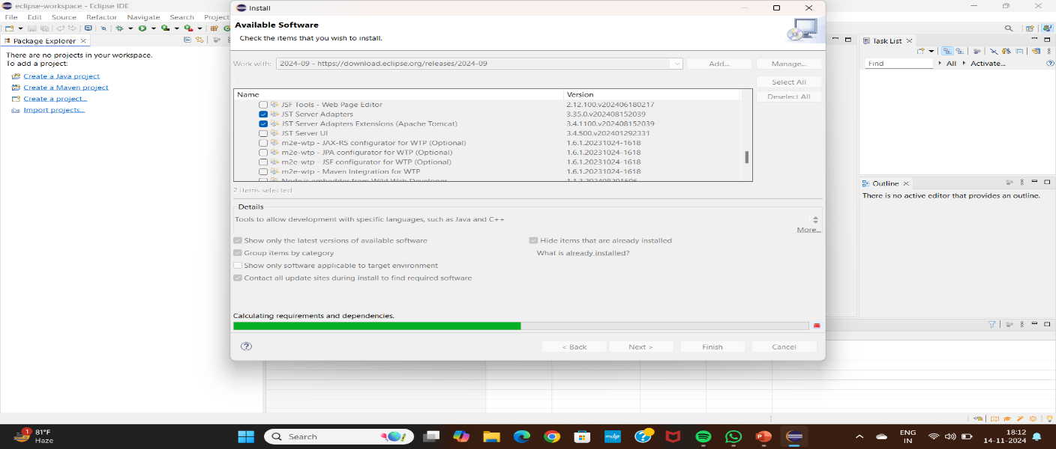

**Step 7:** Click on Next.

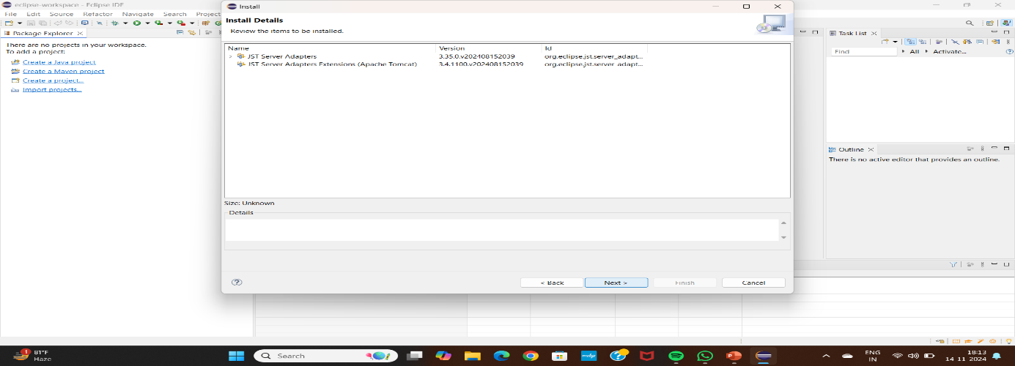

**Step 8:** Click on I agree.

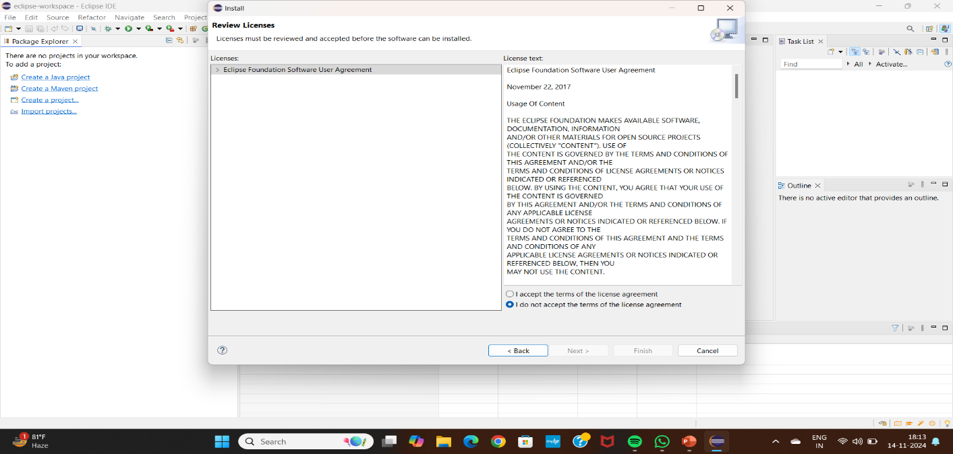

**Step 9:** Select on -> I accept -> Finish .

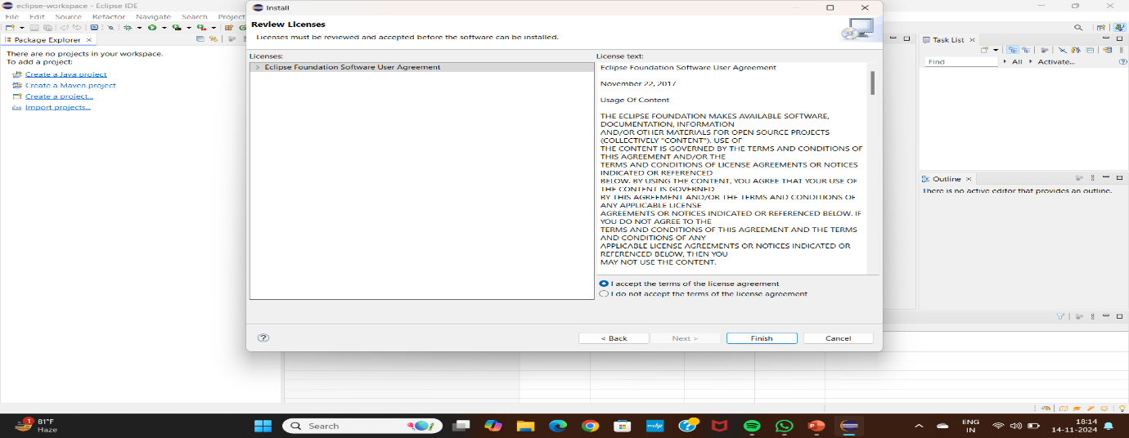

**Step 10:** Restart the eclipse IDE.

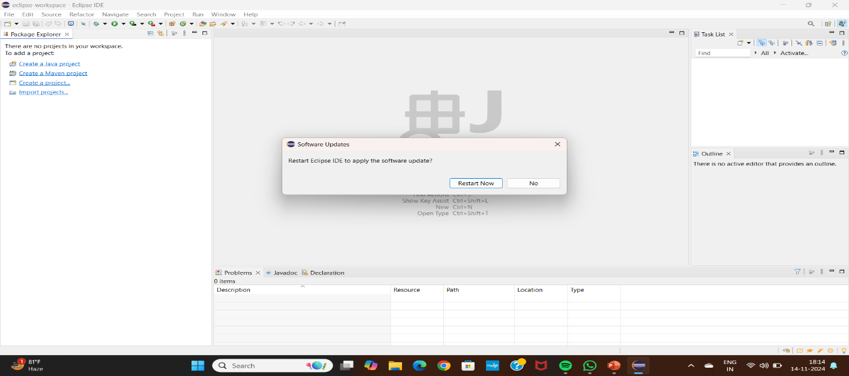

**Step 11:** After the shown installation, check whether server is available in eclipse as shown.

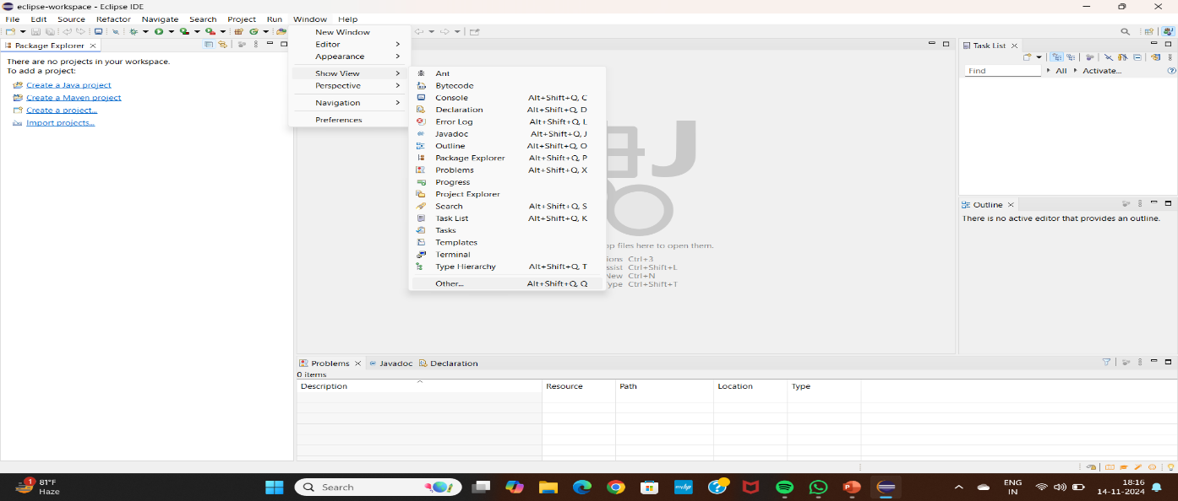

**Step 12:** In Show View, we can now see Servers.

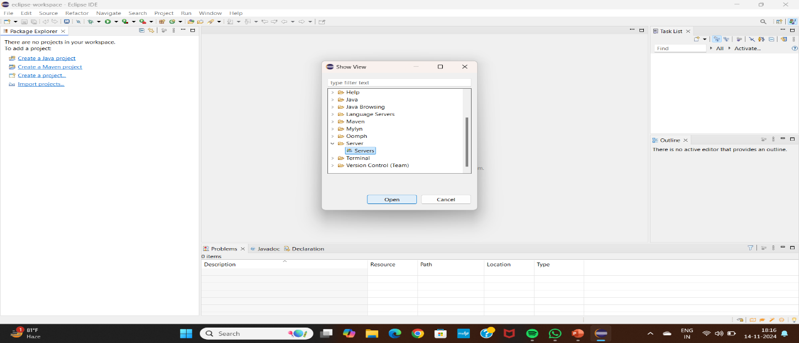

**Step 13:** Click on Apache folder.

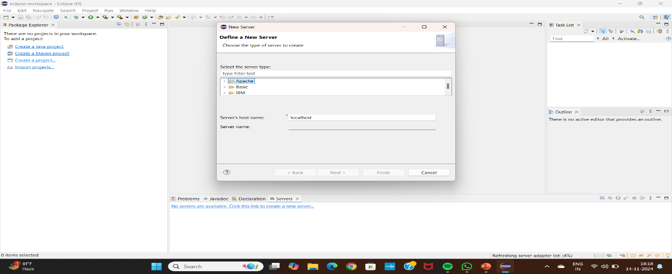

**Step 14:** Select Tomcat V 9 as shown.

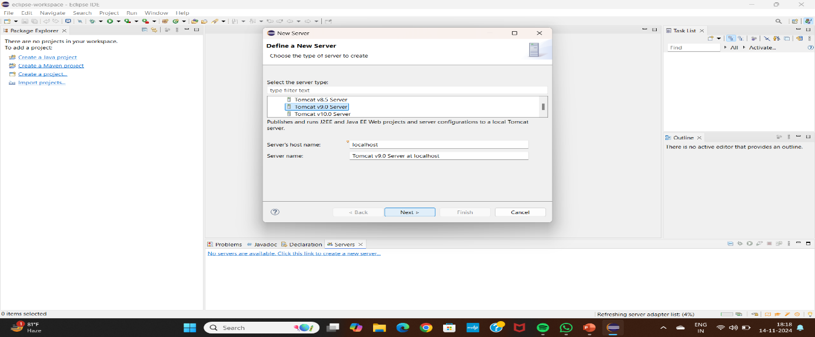

**Step 15:** Browse the Tomcat folder available in your local system as shown.

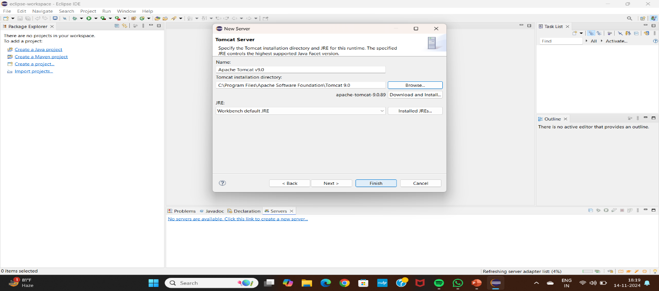

**Step 16:** From now on we can start Tomcat server from Eclipse IDE as shown.

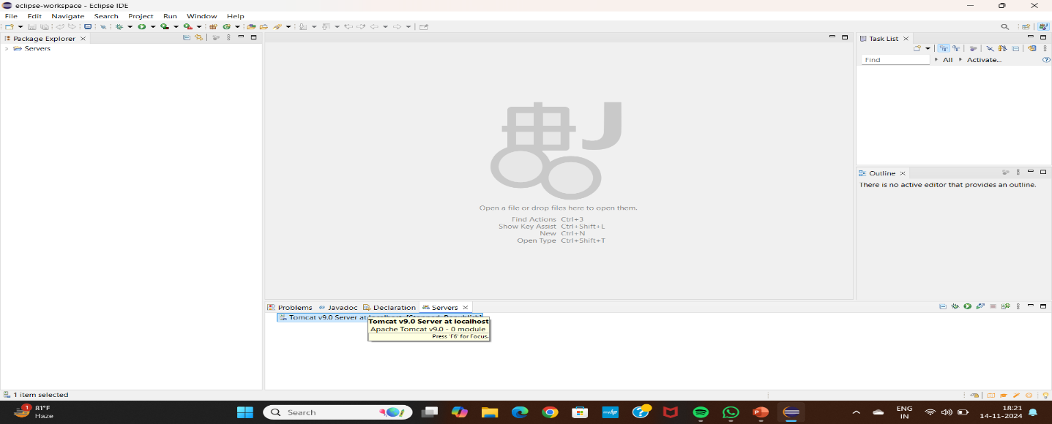

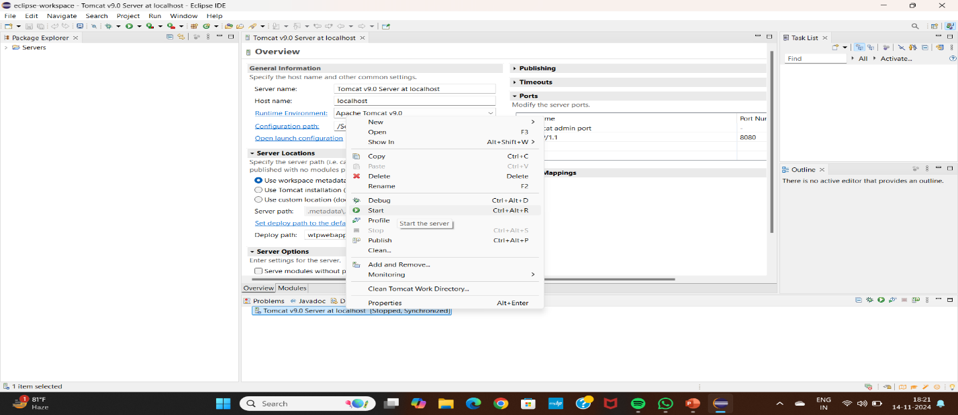

**Step 17:** We can now see that the server is started.The next step is to change the port number

of the Tomcat as Jenkins uses 8080, as shown.

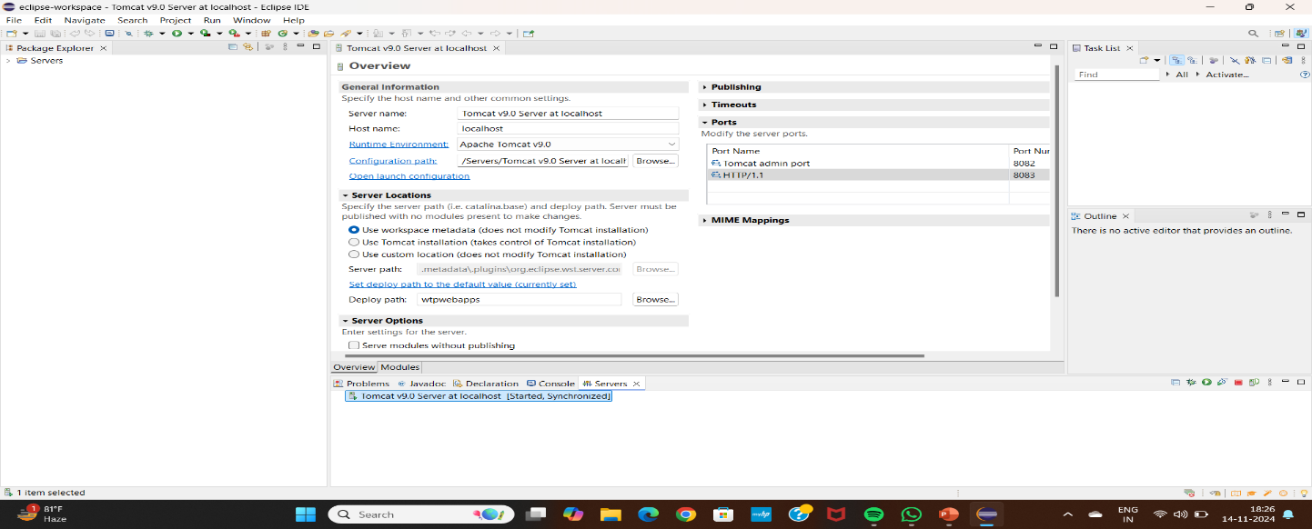

**Step 18:** After the changes, click on save.

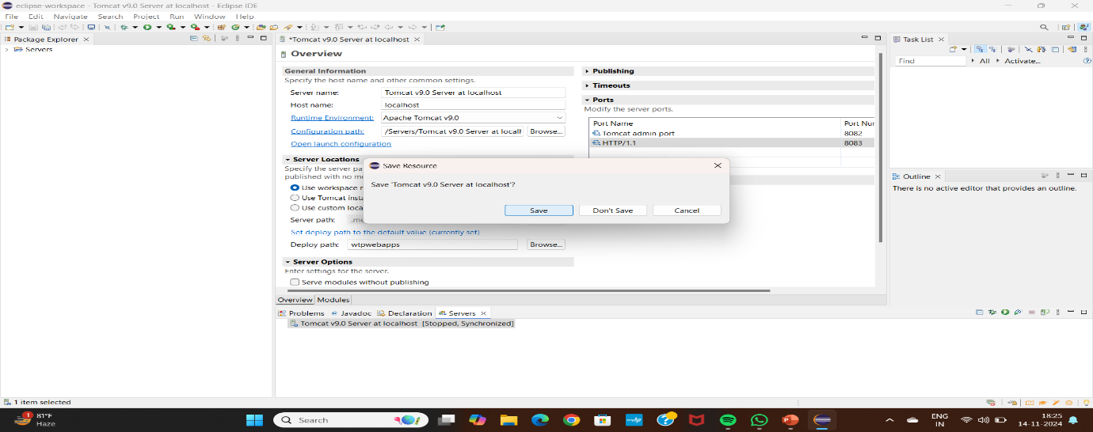

**Step 19:** In server locations make sure second option is selected.

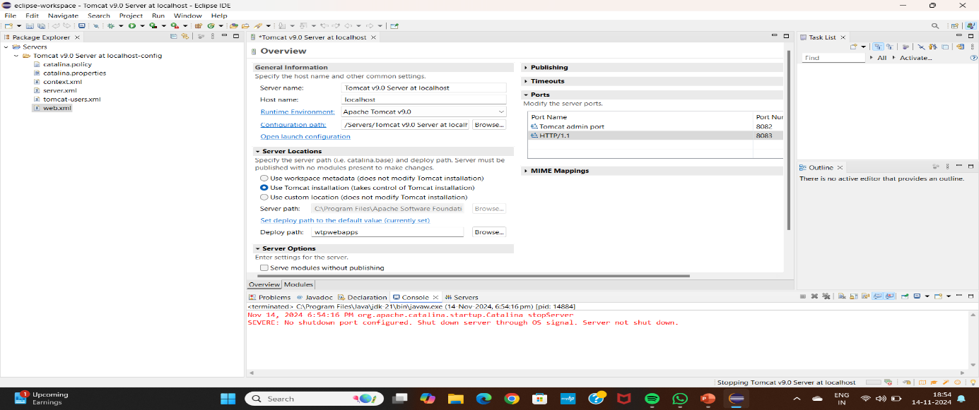

**Step 20:** Copy the following text in the location shown in the below slides.

<role rolename="admin-gui,manager-gui ,manager-script,manager-jmx,manager-status"/>

<user username=“admin" password="1234"roles="manager-gui, admin-gui ,manager-script"/>

Open the tomcat-users.xml file as show, and add the highlighted text in the last.

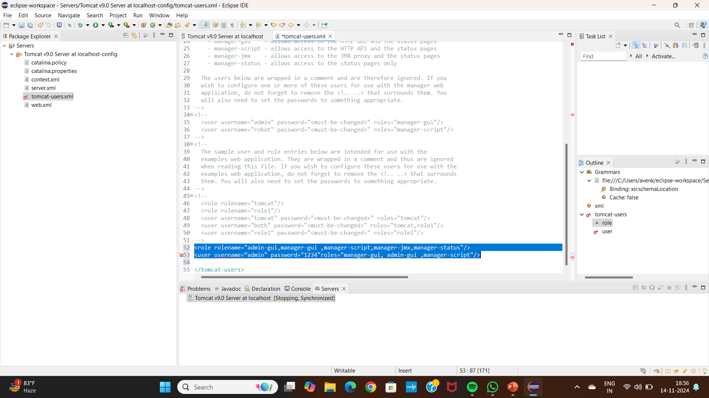

**Step 21:**Now restart the server.

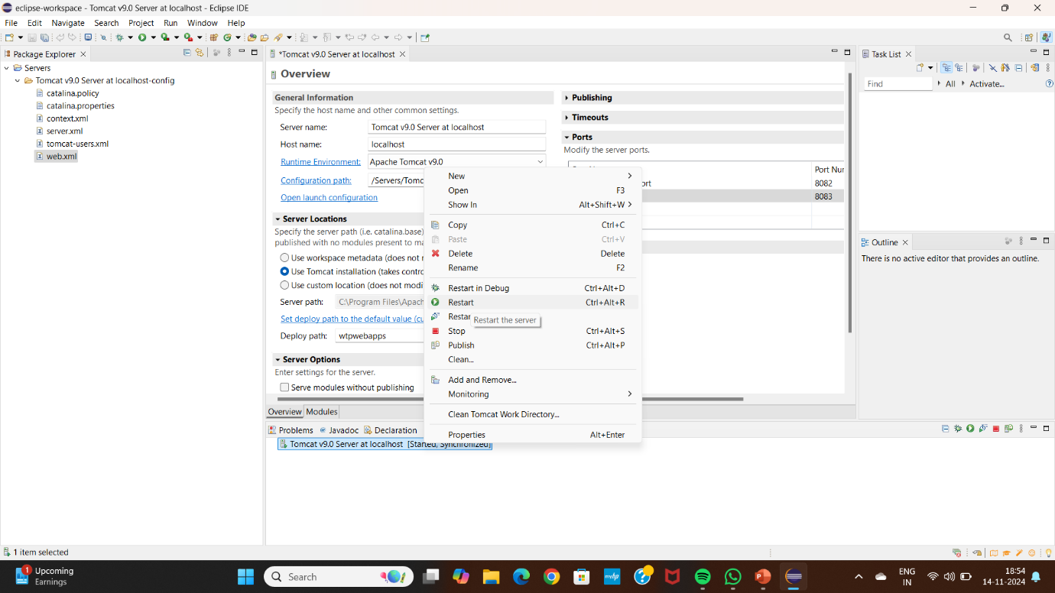

The server gets restarted as shown

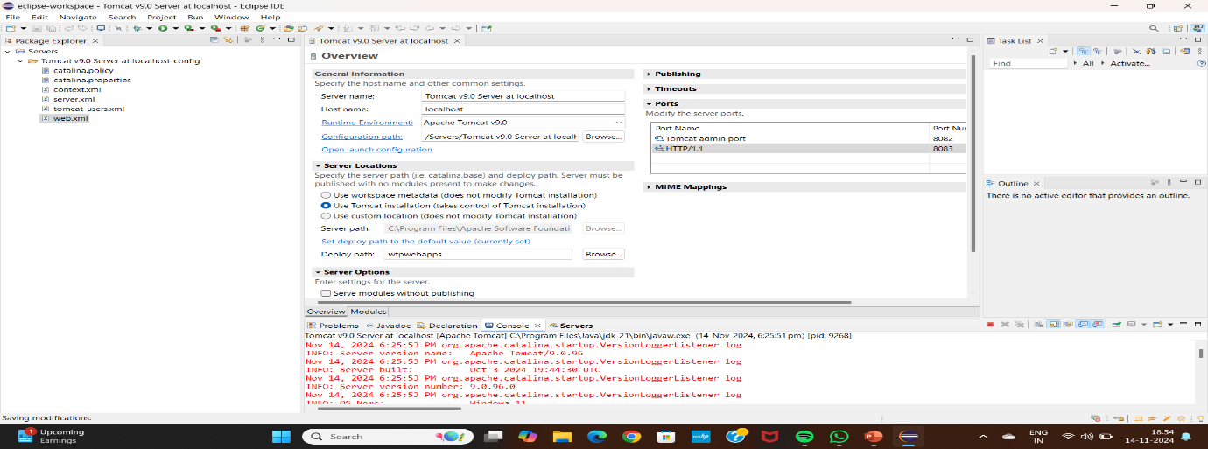

It should show server started

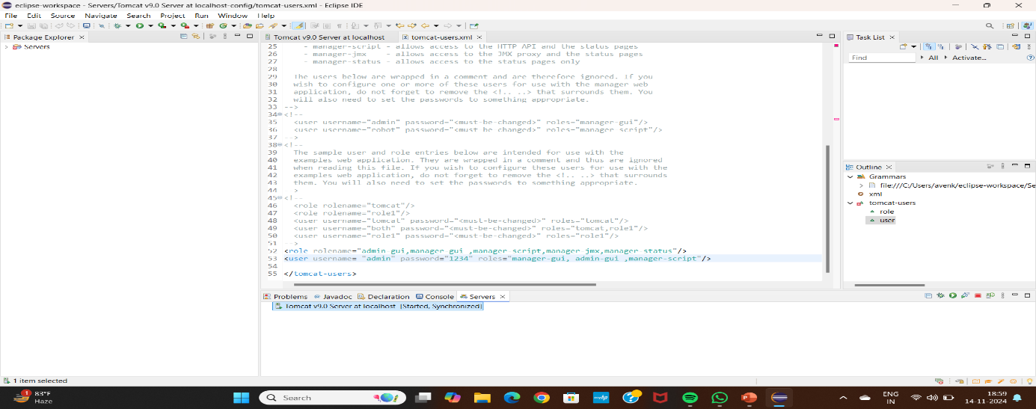

**Step 22:**We can see the Tomcat is successfully running on the new port number.

